**Assignment 13.2**

A Fibonacci series (starting from 1) written in order without any spaces in between, thus

producing a sequence of digits.

Write a Scala application to find the Nth digit in the sequence.

○ Write the function using standard for loop

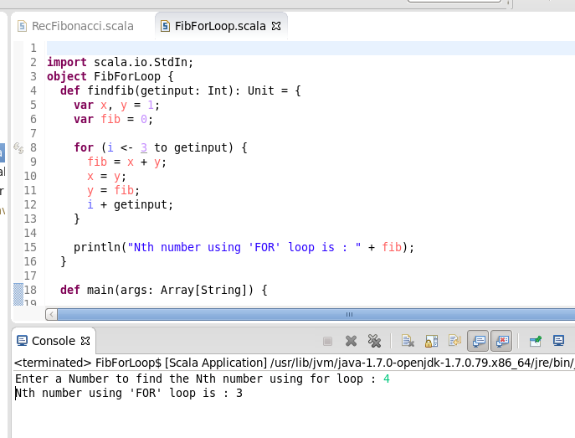

○ Write the function using recursion

